Output:
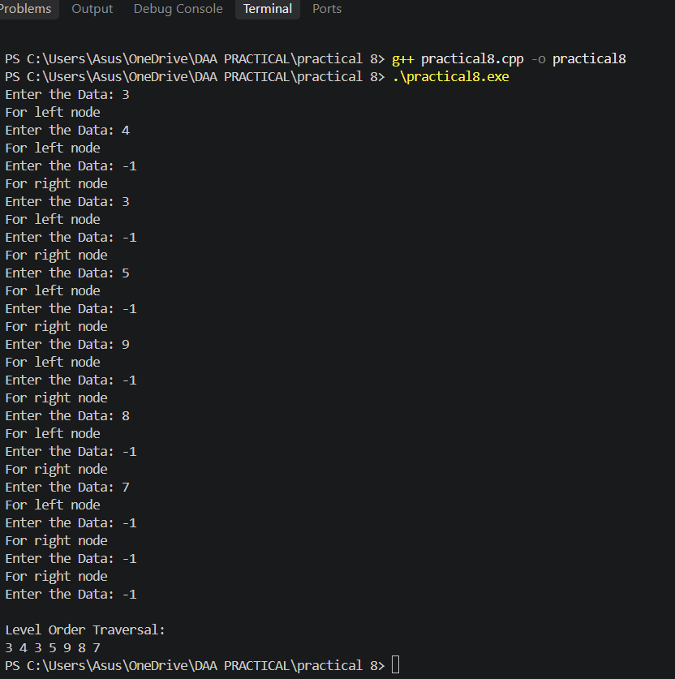

Conclusion:
Thus, the BFS or Level Order Traversal of a binary tree was successfully implemented using a queue. The binary tree was created recursively, and each node was visited level by level from left to right. The program successfully displayed all the nodes in level order, demonstrating the working of BFS traversal.

